**PRCS252 – Travel Management System: Cognitive Walkthrough**

**(Mobile Application)**

**Q1: How would you describe your experience with the app?**

Feedback:

* Very straightforward
* Easy to use booking system
* Not a lot of general improvements but better navigation control and meaningful identifiers on buttons.

• On a scale of 1 – 5 (1 being most easy, and 5 being most difficult), how did you find completing the tasks set?

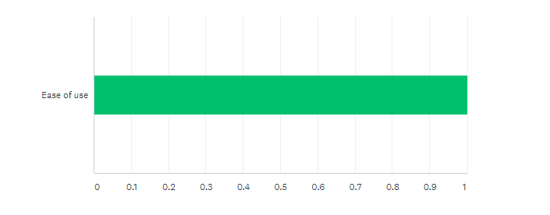

**Q2: On a scale of 1 – 5 (1 being mostly bad, 5 being mostly good), how would your rate your overall experience with the app?**

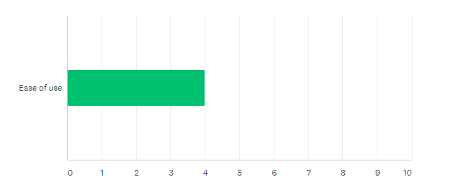

**Q3: What features, if any, did you have difficulty using?**

* Maybe navigating to previous bookings due to mildly confusing button names.

**Q4: Is there anything you feel the app is missing usage-wise? (E.g. anything you feel would make it easier to use?)**

* Cancel tickets functionality.

**Q5: What was, if any, your favourite feature of the app to use and why?**

* Simplistic and minimal design
* Streamlined navigation.

**Q6: What was, if any, your least favourite feature of the app to use and why?**

* Lack of cancel ticket functionality.

**Q7: How did you feel when using the app’s navigation?**

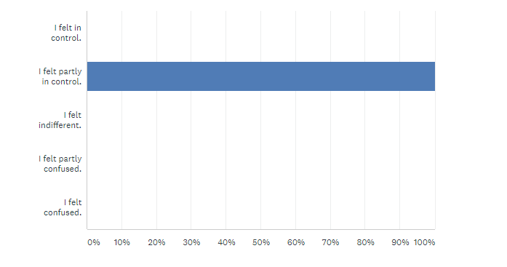

**Other Improvements:**

• Ability to cancel tickets

• Bookings and view bookings buttons are ambiguous

• Replacement service information for the customer must be shown e.g. notification or updates.